Giardiasis
Giardia is a microscopic parasite that causes the diarrheal illness known as giardiasis. Giardia (also known as Giardia intestinalis, Giardia lamblia, or Giardia duodenalis) is found on in soil, food, or water that has been contaminated with feces from infected humans or animals.
Giardia is protected by an outer shell that allows it to survive outside the body for long periods of time and makes it tolerant to chlorine disinfection. although the parasite can be spread in different ways, water (drinking water and recreational(المياه الترفيهية) water) is the most common method of transmission.
Life Cycle:
Cysts are resistant forms and are responsible for transmission of giardiasis. Both cysts and trophozoites can be found in the feces (diagnostic stages) . The cysts are hardy and can survive several months in cold water. Infection occurs by the ingestion of cysts in contaminated water, food, or by the fecal-oral route (hands or fomites) . In the small intestine, excystation releases trophozoites (each cyst produces two trophozoites) . Trophozoites multiply by longitudinal binary fission, remaining in the lumen of the proximal small bowel where they can be free or attached to the mucosa by a ventral sucking disk . Encystation occurs as the parasites transit toward the colon. The cyst is the stage found most commonly in non diarrheal feces . Because the cysts are infectious when passed in the stool or shortly afterward, person-to-person transmission is possible through fecal – oral route .
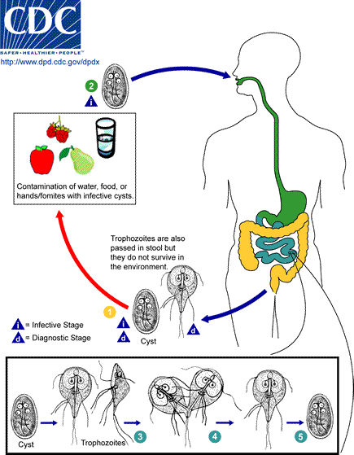
Clinical Presentation
The spectrum varies from asymptomatic carriage to severe diarrhea and malabsorption. Acute giardiasis develops after an incubation period of 1 to 14 days (average of 7 days) and usually lasts 1 to 3 weeks. Symptoms include diarrhea, abdominal pain, bloating, nausea, and vomiting. In chronic giardiasis the symptoms are recurrent and malabsorption and debilitation may occur.
Laboratory Diagnosis
Giardiasis is diagnosed by the identification of cysts or / & trophozoites in the feces,
- laboratory diagnosis using : 1- direct smears 2- The use of concentration methods and 3- staining trichrome hematoxylin iron.
Because Giardia cysts can be excreted intermittently, multiple stool collections (i.e., three stool specimens collected on separate days) increase test sensitivity . because variability in the concentration of organisms in the stool can make difficult to diagnose this infection.
- fecal immunoassays (antigen detection tests by enzyme immunoassays), and detection of parasites by immunofluorescence that are more sensitive and specific should be used.
- samples of duodenal fluid (e.g., Enterotest) or duodenal biopsy may demonstrate trophozoites.
- The molecular testing (e.g., polymerase chain reaction PCR) can be used to identify the subtypes of Giardia.
Treatment
Several prescription drugs are available to treat giardiasis including metronidazole and tinidazole. Nitazoxanide has provided some encouraging results in the management of giardiasis in children.

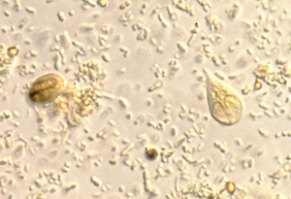
Cyst & trophozoite of Giardia in wet mount

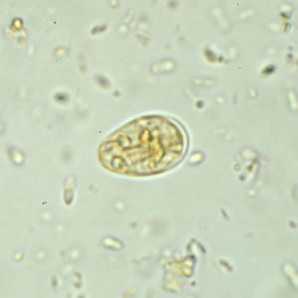
Giardia duodenalis cysts are oval to ellipsoid and measure 8-19 µm (average 10-14 µm). Mature cysts have 4 nuclei, while immature cysts have two. Nuclei and fibrils are visible in both iodine-stained wet mounts and trichrome-stained smears
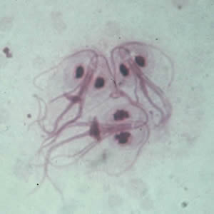
Giardia duodenalis trophozoites in Giemsa stain are pear-shaped and measure 10-20 micrometers in length. In permanent, stained specimens, 2 large nuclei are usually visible. The sucking disks (used for attaching to the host’s mucosal epithelium), median bodies, and flagella (8) may also be seen.
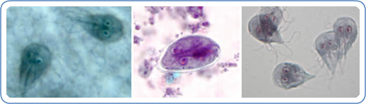
Left: G. intestinalis trophozoites in Kohn stain. Center: G. intestinalis cyst stained with trichrome. Right: G. intestinalis in in vitro culture.

